**Executive Summary**

X-Cali was founded in September 2017 with five shareholders who are young and talented engineers. The main purpose of the company is to make the qualified technologic products affordable for everyone. Various control projects, software and hardware development are main interests of X-Cali.

The engineers of X-Cali are gaining experience with each single project. Their main motivation is to find innovative solutions to complicated problems. Collaboration between them is at top level. They work in harmony and try to do their best in each project.

The first project of the X-Cali is composed of two robots carrying a plank collaboratively through a maze. There are some physical restrictions for the robots and rules for the maze solving process. For example, direct communication between the robots is not allowed. There will be two modes for the robots which are master and slave modes. Master robot will go first through the maze and slave robot will follow. The complexity of making L-turns and U-turns without direct communication between the robots makes the problem complicated.

A planned and systematic study has been conducted by the engineers of X-Cali. In order to increase the chance of achieving the goal, different approaches to the problems were analyzed and all the possibilities were considered. Implementation of the hardware and software subsystems of the project was conducted according to specifications and constraints that are determined by the Standard Committee.

**Introduction**

This report describes the hardware and software progress and implementations carried out so far.

As the company X-Cali, we have completed most of the hardware implementation of the project. Physical architecture of the robot has been designed and almost finalized. We have also remarkably proceeded at the software part of the project. For subsystems, the design procedure was completed and final decisions were made. Even though we do not have a full functioning robot now, we made tests on subsystems and the results of these tests are included in this report.

Detailed description of the overall system and subsystems are given in this report. Technical details of designed systems were explained. Moreover, block diagrams, flow charts and 3D technical drawings of the subsystems are included. At the “Modifications to Conceptual Design” part, all the development and modifications to the system were clearly clarified. The cost and risk analyses of the robot are made. Finally, we mentioned our future plans in “Development Schedule”.

**Conclusion**

The engineers of the company X-Cali have prepared this report in order to inform customers about the progress of the project implementation. The present situation of the project was explained elaborately. The detailed solutions we have come up with were included.

All the subsystems, modifications to the conceptual design, the risk analysis and safety issues were included. Necessary tests were made for the subsystems. The test procedures were explained and the test results were interpreted in this report. Detailed explanations of the overall system and subsystems were given. Team members went shopping last week and bought necessary components, hence the cost table was updated. Gantt Chart was also updated.

At this point, we can say that our robot is almost ready. Our design and implementation is almost finished, only slight improvements will be done. We are working to succeed and finish this project as soon as possible.

**Modifications to Conceptual Design**

In the Conceptual Design Report, different solution approaches and details of both software and hardware parts of the project were explained. After the report was submitted, we made some tests and evaluated advantages and disadvantages of the choices we made in hardware components. According to the results of this evaluation, we decided to modify some parts of the hardware of the project. These modifications are as follows:

* Arduino will be used for motor control since we already have a motor control code that works properly in Arduino.
* We added Infrared Sensor to the robot just in case Ultrasonic Sensors does not work properly.
* We decided to add an extra camera which means robot will have two cameras instead of a single camera. The reason for this is that both the movement of the plank and top of the maze could not be observed with a single camera.
* The motors we used in the demo in first semester was not powerful enough. Hence, we have bought new motors that are powerful enough and have encoders. Encoders was needed for obtaining direction information. The data which is coming from encoder will be processed in Arduino.



Figure : New motor with encoder

**Social Utility and Deliverables**

The first robot of X-Cali is designed for general usage. There is no specific client profile for our product. The robot can be used for different purposes such as gaming or educational purposes.

The expected deliverables of the work packages of our project can be seen in Table.

|  |  |  |
| --- | --- | --- |
| **The Work Package** | **Corresponding Deliverable** | **Status** |
| Research | Tentative Report | Completed |
| Component Tests | Results and analysis of the component test | Completed for the ultrasonic sensors and RP3.  Test plan is achieved. |
| Communications Subsystem  Design | Results of the procedure of receiving& processing data | Not completed. |
| Mechanical Subsystem Design | Driving tests and analysis of the robot | Completed. Test plan is achieved. |
| Software Subsystem Design | Documentation of the algorithms and debugging results | Started but not completed. |
| Overall System Implementation& Tests | A robot completing the labyrinth by itself | Not completed yet. |
| Demonstration | A robot completing the labyrinth collaboratively with the other groups.  The product within its package. | Not completed. |

Table : Expected Deliverables of the Work Packages of the Project

The package of our product will include the main body of the robot, a plank, user manual, 2 spare tires, a backup battery and a remote controller deciding the robot to become master or slave.

The size of the robot can be adjusted according to the customers demands. The product will be prepared in 10 weekdays after the order. Users can find all the necessary information about the product in the user manual.

You can contact us via our web site <http://www.xcali.ml>.

**Component Analysis**

One of the most important and critical step in progress of development of the project is component selection. We made necessary researches and with respect to the results of these researches we chose the components of our robot. These selections are given as follows:

* **Microcontroller**

Our criterias while choosing the microcontroller was speed, low price and compatibility. After some research, we concluded that Arduino Uno is the best option for us since it is cheap, fast and compatible.

It has 28 pins including 16 digital pin, 6 analog pin, 5 power pin and a reset pin. These are enough for our needs.

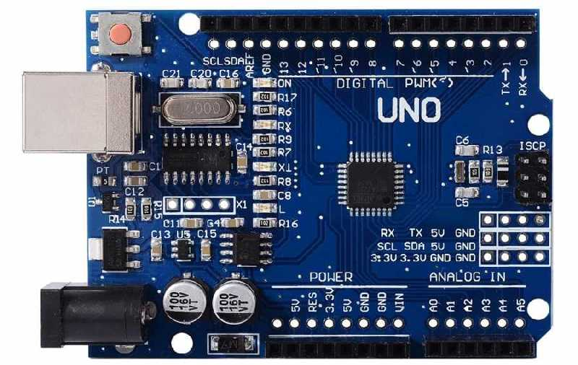

Figure : Arduino Uno

* **Main Computer**

We needed to choose mini computer that has the highest performance/price ratio. We also had to consider our budget and choose the computer accordingly. Raspberry Pi 3 was chosen.

Raspberry Pi 3 has HDMI, USB 2.0 and Ethernet connections, Camera Serial Interface, Display Serial Interface and 40 general purpose input/output pins.

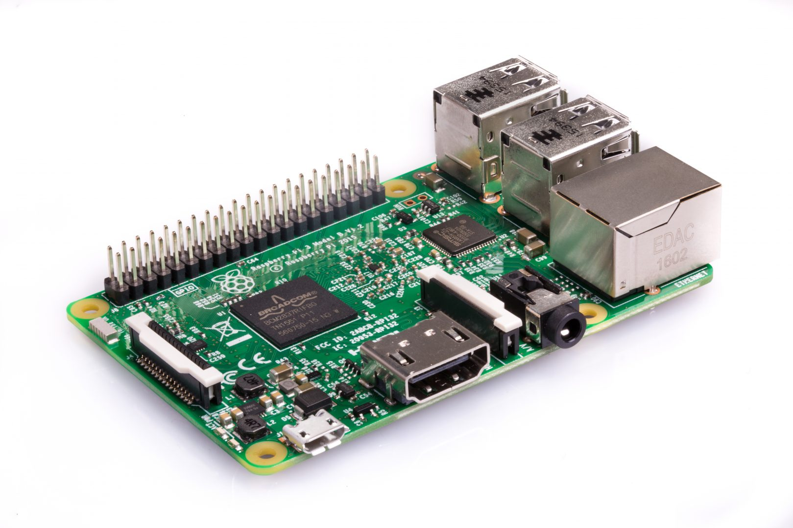

Figure : Raspberry Pi 3

* **Motor with encoders**

We selected a powerful enough motor with encoders. The data coming from the encoders will be processed in Arduino. Encoder data is important since it provides the robot with direction information.



Figure : The motor

* **H-Bridge**

Our priority was to select a H-Bridge that is cheap and compatible with the other parts of the robot. We chose L298N H-Bridge since it satisfy our requirements.

Two DC motor can be controlled with L298N in both directions. It provides 2 A current in maximum case.

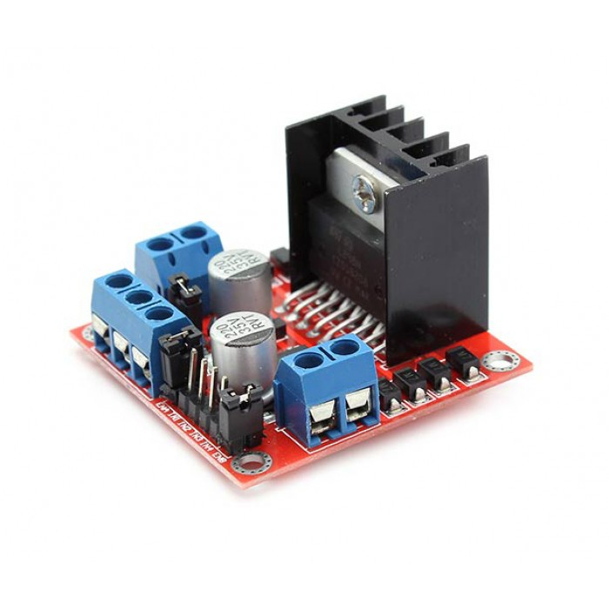

Figure : L298N H-Bridge

* **Battery**

We needed to select a battery that is cheap, compatible with the other parts of robot, easy to use and easy to find information. We decided that the best choice is Li-Po battery.

* **Camera**

Camera selection was one of the most critical parts of the project since our main solution relies on camera. After some research, we considered the performance/price ratios and decided to select a Bewell camera. It is a cheap camera, we can change it with a better one if our budget lets us.

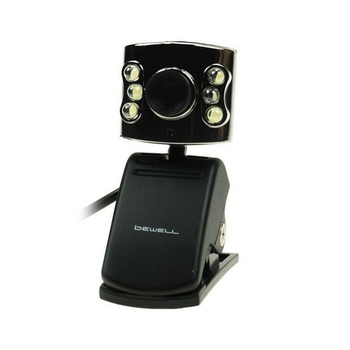

Figure : Bewell Camera

* **Sensors**
  + **Ultrasonic Sensor**

We used ultrasonic sensor in order to measure the distance. HC-SR04 was chosen for this purpose.

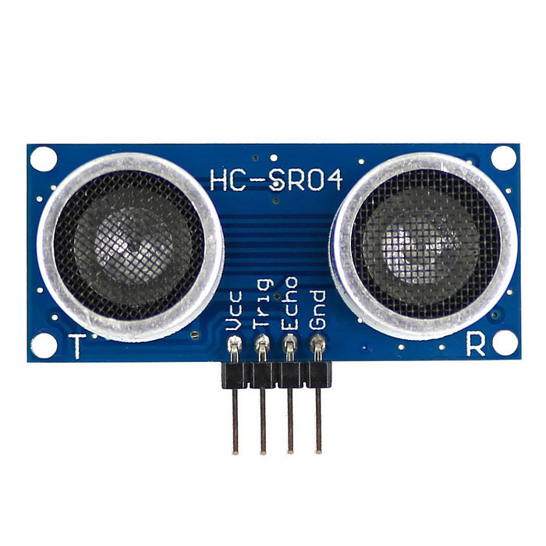

Figure : Ultrasonic Sensor HC-SR04

* + **IR sensor**

IR sensor is also used for distance measurement.

* **Chassis & Mad Wheel**

We selected a wooden chassis which forms main body of the robot. It has several holes for motor connections, sensors, circuit cards and other components. Mad wheel is chosen as third wheel since it provides the robot with maneuverability.